Click Step here

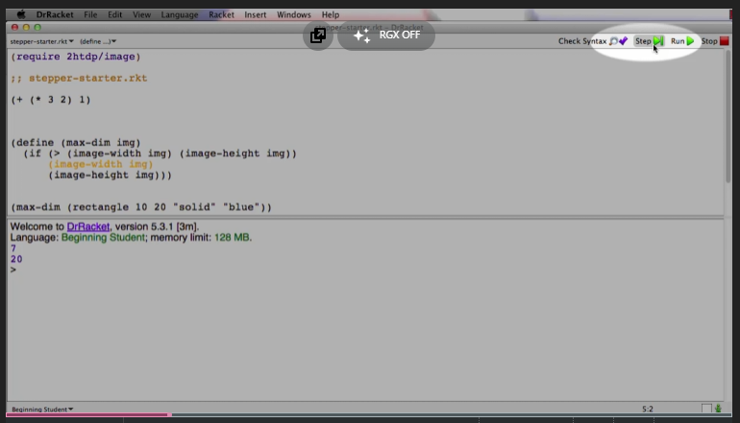

You can now see the evaluation step by step (by the rules of BSL)

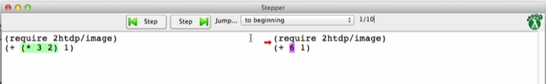

Just click on Step >| or Step |< according to your need to navigate through the steps